BLOCKCHAIN BASED SECURE UNMANNED TRAFFIC MANAGEMENT SYSTEM FOR INTERNET OF DRONES
WHY DRONES?
Drones have many uses like civilian applications including monitoring climate change, transporting goods, assisting research and rescue operations, agriculture and military applications as remote-guided aerial missile launchers.
STRUCTURE OF DRONES:
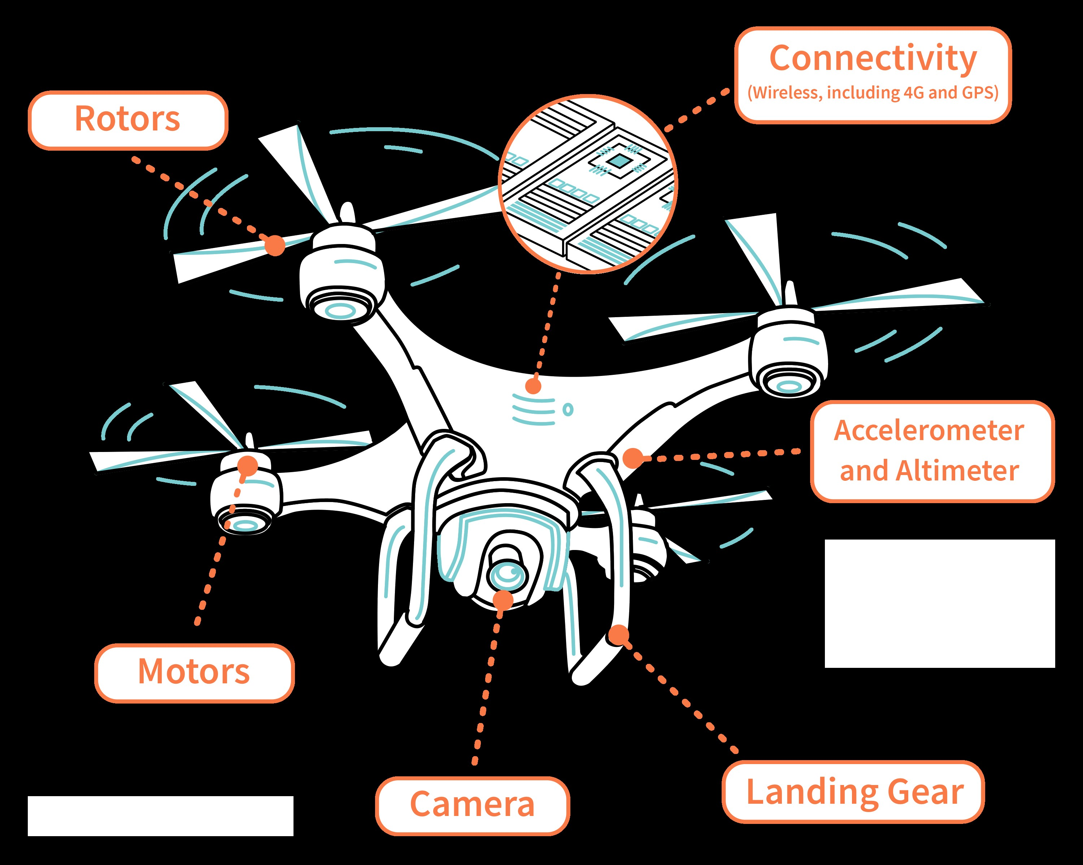
FREQUENCY OF DRONES: 2.400-2.483 GHZ AND 5.725 -5.825 GHZ BAND
ARCHITECTURE OF DRONES:
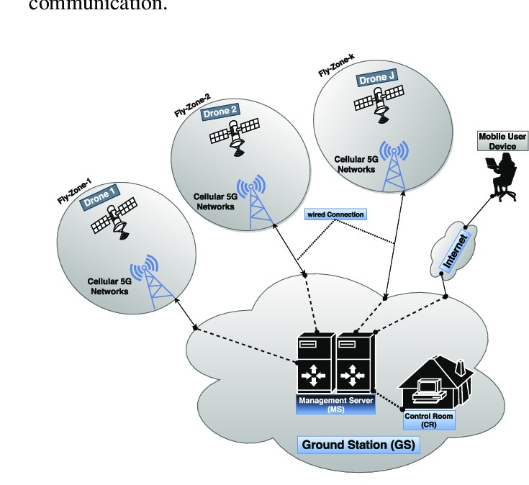
NETOWRK USED: LTE
CENTRALIZED NETWORK:
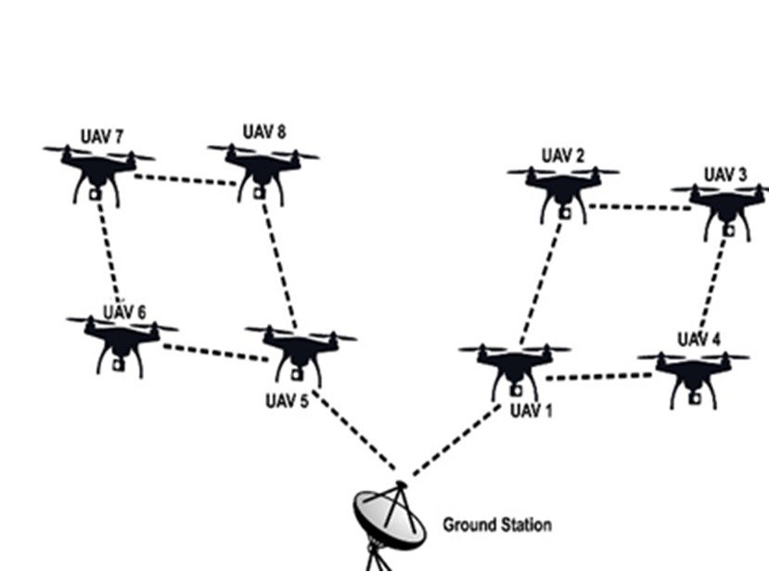
LITERATURE SURVEY:
SL NO. | TITLE | AUTHOR, MONTH AND YEAR | JOURNAL | PROPOSED TECH | LIMITATIONS
1 | The blockchain: A new framework for robotic swarm systems | Ferrer et al  (2018) | In proceeding s of the Future Technologies Conference | Key and digital signature cryptography, UAV,BC | Description of the approach is quickly provided, and no implementations or simulations were realized
2 | Robust Trajectory and transmit power design for secure UAV Transmissions  And  Securing UAV communications via joint trajectory and power control | Cui et al and Zhang et al  (2019) | IEEE | Adjusting UAV trajectory and transmitting power by using a physical layer based approach | How the solution will work with multiple UAVs?
3 | Sustainable and secure trajectories for the military Internet of Drones(IOD) through an efficient Medium Access Control(MAC) Protocol | Choudhary et al(2019) | Comput.Elec.  Eng | MAC Protocol, and deep neural network | Location privacy is not considered

4 | Security in networks of unmanned aerial vehicles for surveillance with an agent based approach inspired by the principles of blockchain | Garcia Magari  Et al(2019) | Ad Hoc Netowrk | PoA ,smart contract, asymmetric key encryption | Focus only on detecting whether UAV is hijacked or not

3. PROBLEM:
Usage of IOD in UTM introduces challenges such as
- Increasing the risk of vulnerabilities like spoofing attacks and data manipulation
- Increased risk of collision
- Incorrect adversaries
- Undesired and unknown flight paths can occur
- Attack of confidentiality, integrity and availability of UtM
- Cost effective solutions needed.

4. SOLUTION:

Usage of blockchain and cryptographic applications may increase security in UAV’s.

5. BLOCK DIAGRAM:
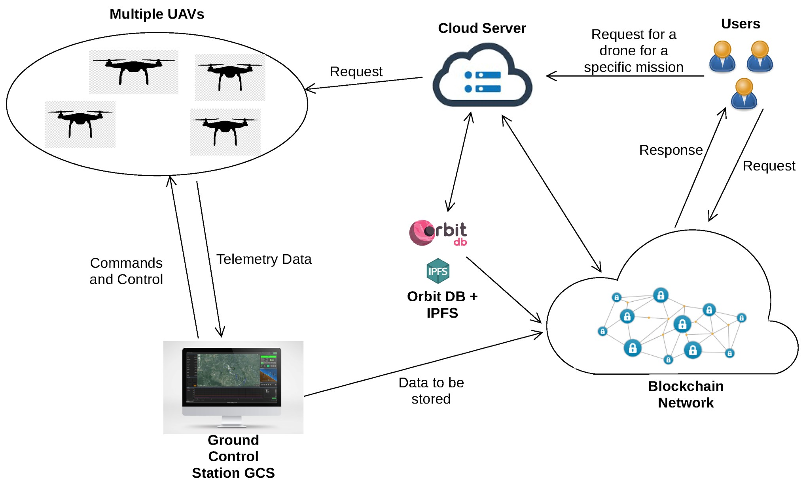

- FLOWCHART:
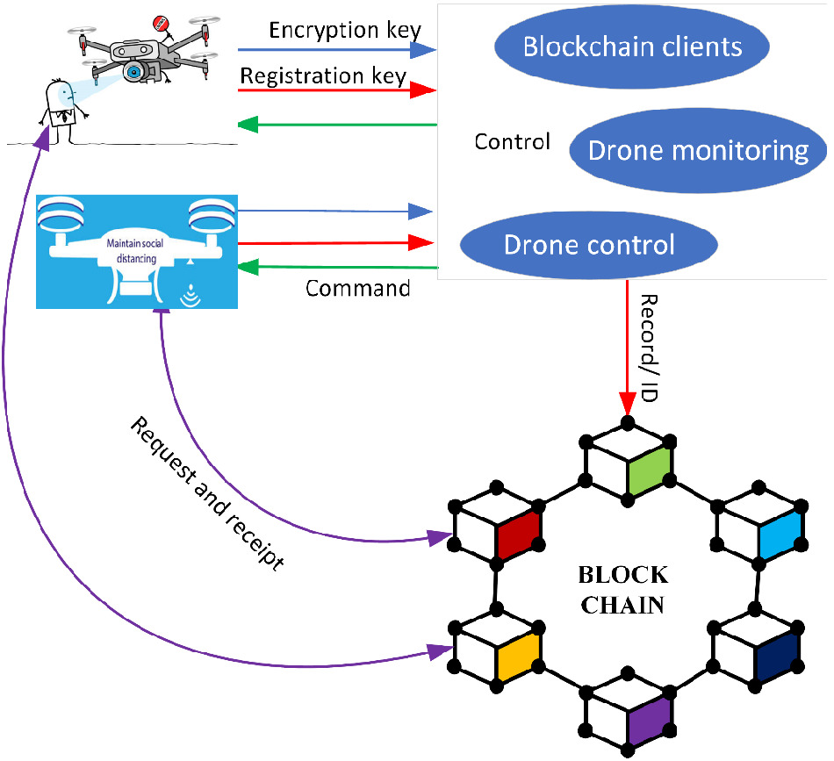

- ADVANTAGES:
The use of blockchain technology in the Internet of Drones (IoD) offers several advantages. One of the key benefits is enhanced security. Blockchain provides a decentralized and tamper-proof system that can help protect the integrity and confidentiality of data in IoD applications. It ensures that information transmitted between drones, ground stations, and other stakeholders is secure and cannot be easily altered or manipulated <<2>>.
Another advantage is transparency and traceability. Blockchain enables the creation of an immutable record of all transactions and activities within the IoD ecosystem. This allows for enhanced accountability and auditability, as stakeholders can easily track and verify the history of events related to drone operations <<3>>.
Additionally, blockchain facilitates interoperability and trust among various participants in the IoD network. It provides a decentralized platform where drones, service providers, regulators, and other entities can securely interact and exchange data. Smart contracts, which are self-executing agreements stored on the blockchain, can automate and streamline processes, enabling seamless collaboration and efficient resource allocation <<1>>.
Furthermore, blockchain technology can address privacy concerns in the IoD domain. While drones collect large amounts of data, ensuring the privacy and confidentiality of sensitive information is crucial. Blockchain's encryption mechanisms and user-centric control over data access and permissions can help protect privacy rights and maintain data sovereignty <<2>>.
In summary, the advantages of using blockchain in the Internet of Drones include enhanced security, transparency, traceability, interoperability, and privacy protection. These benefits contribute to the development of a reliable and trustworthy ecosystem for drone operations.

8. PERFORMANCE METRICS:

- Cost
- Latency
- Processing time
- Security
- Immutability
- Tamper Proofing
- Transparency
- Privacy
- Preservation
- Defend Rate
- Reliability
- Stability

- SIMULATION PLATFORM:
Hyperledger Fabric is a distributed ledger software and an open-source blockchain framework hosted by The Linux Foundation. It is designed to serve as a foundation for developing applications or solutions with a modular architecture <<1>>. Fabric provides a flexible and adaptable platform for building enterprise blockchain networks, capable of supporting a wide range of use cases and business requirements.
Fabric allows multiple organizations to collaborate in a private and permissioned network, where participants can transact with each other in a secure and transparent manner. It uses a modular architecture, which enables developers to customize and extend its features to suit their specific needs. This modularity also allows for better scalability and performance, as different components can be independently upgraded or replaced without disrupting the entire network.
One of the key features of Hyperledger Fabric is its support for smart contracts. Fabric uses a programming model known as chaincode, which allows participants to define and execute business logic on the network. These smart contracts can be written in various programming languages, giving developers flexibility in implementing complex business rules and processes.
Hyperledger Fabric has gained significant adoption in various industries, including finance, healthcare, supply chain management, and more. It provides a robust and reliable infrastructure for building enterprise-grade blockchain solutions that address the unique requirements and challenges of different businesses.
In summary, Hyperledger Fabric is an open-source blockchain framework that offers a modular architecture and supports the development of enterprise blockchain applications. It provides a secure, transparent, and scalable platform for multiple organizations to collaborate and transact with each other.

10. REFERENCES:

